**Fields And Relationship**

* Fields - Fields store data values that are required for a particular object in a record.
* An object relationship in Salesforce is a two-way association between two objects. Relationships are created by creating custom relationship fields on an object. This is done so that when users view records, they can also see and access related data.
* Following is the list of fields of object we have created.

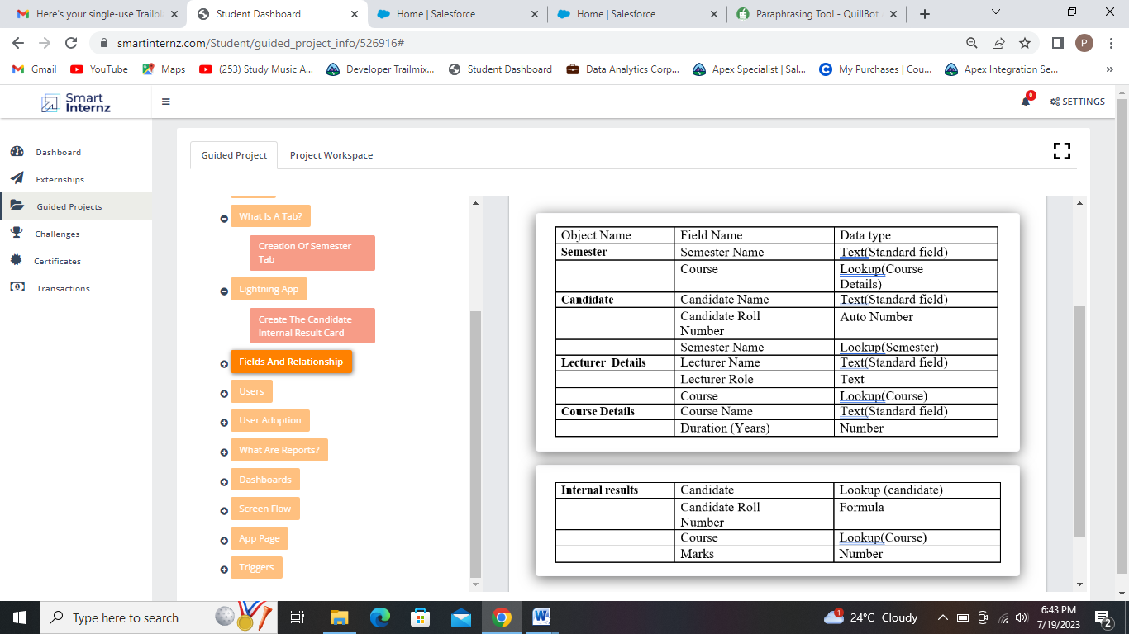

### Creation Of Fields For The “Semester” Object :

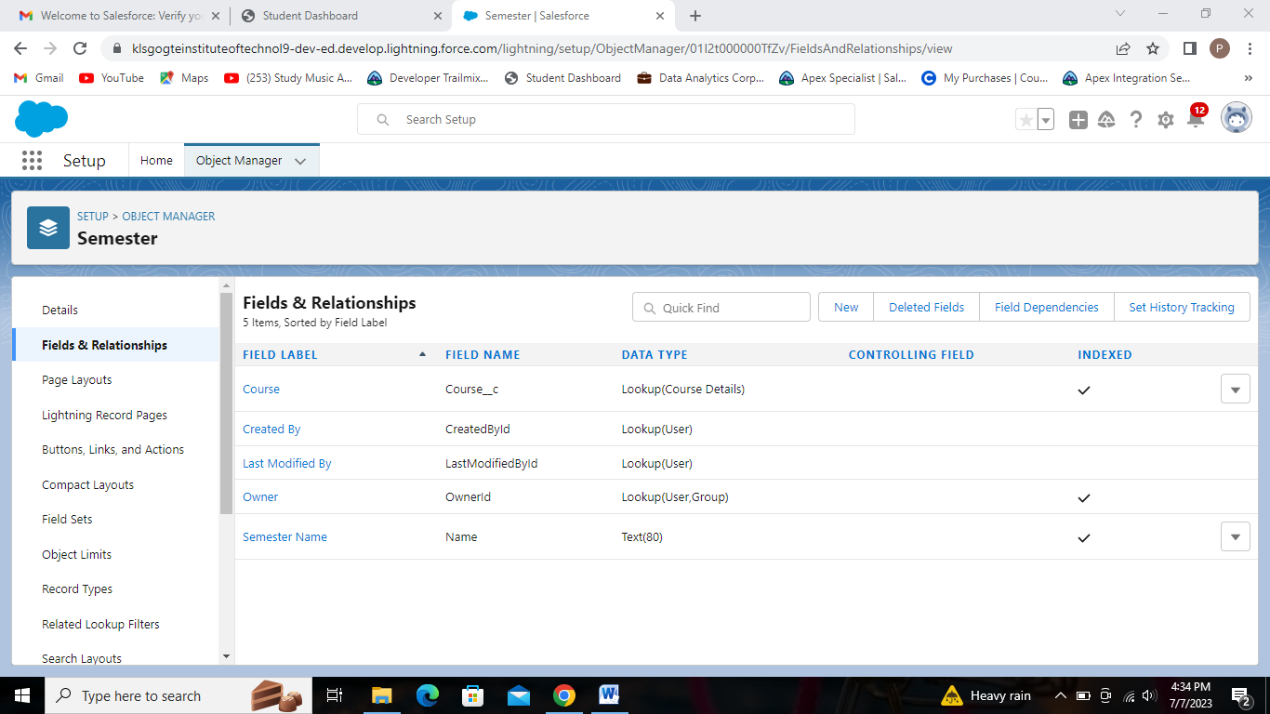

Fields of semester object.

### Creation Of Fields For The “Candidate” Object :

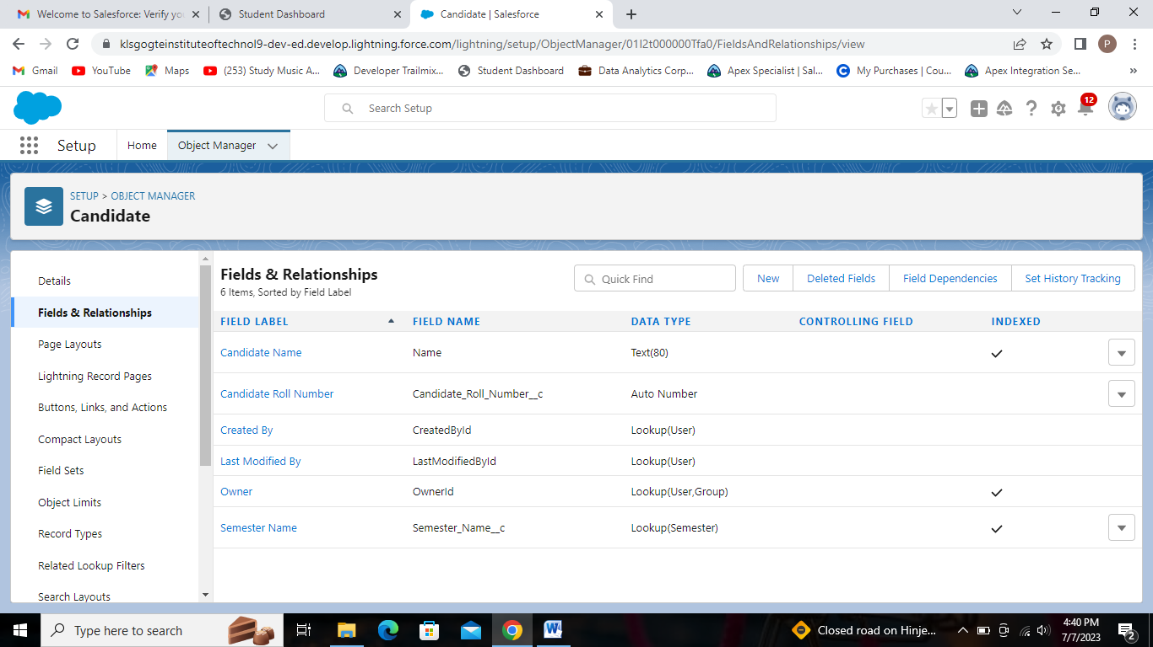

Fields of Candidate object.

### Creation Of Fields For The “Lecturer Details” Object :

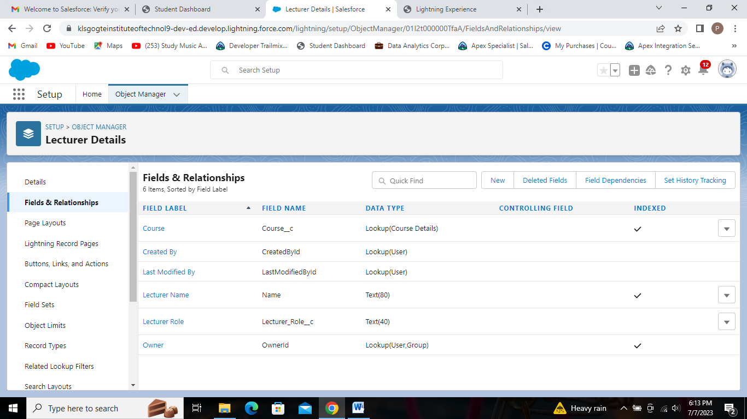

Fields of Lecturer Details object.

### Creation Of Fields For The “Course Details” Object :

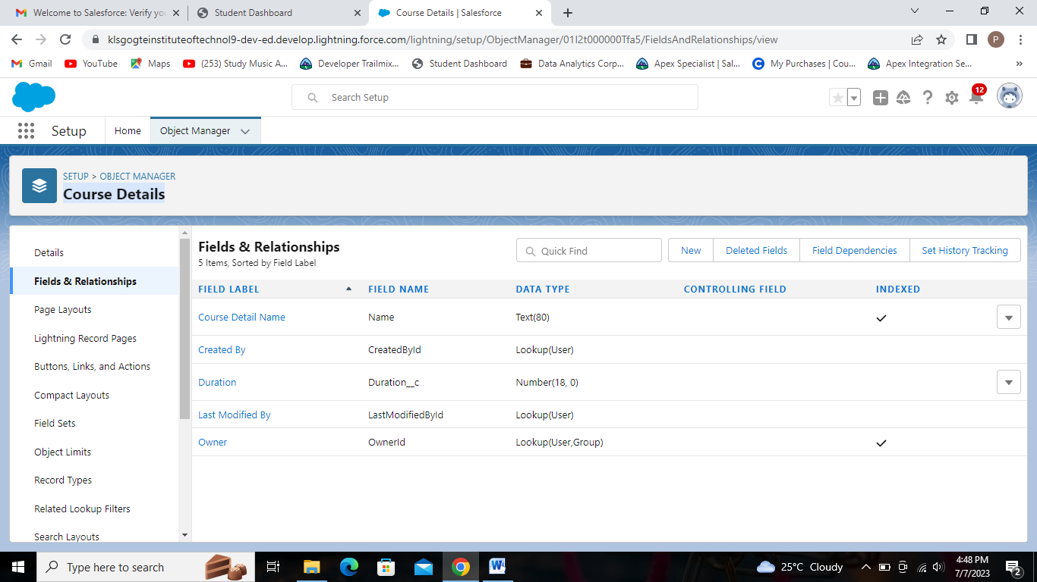

Fields of Course Details object.

### Creation Of Fields For The “Internal results” Object :

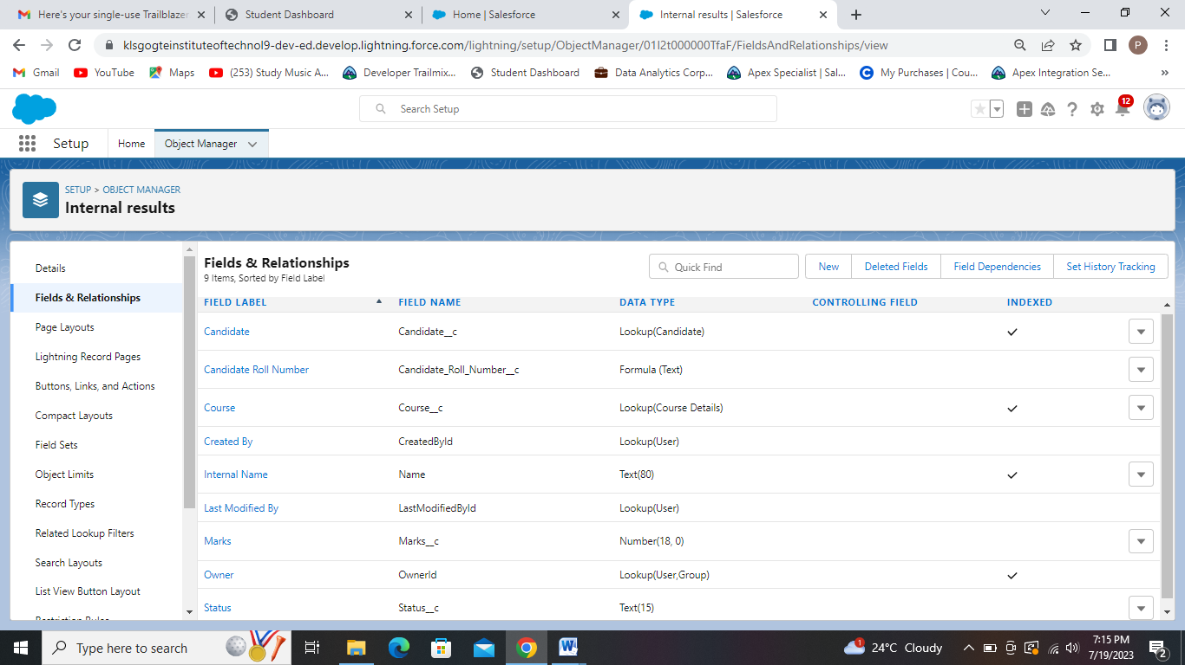Fields of Internal results object.